|  |  |  |  |  |
| --- | --- | --- | --- | --- |
| Fecha | Versión | Incidencias | Entrega | Comentario |
| 2/11/2022 | Inicial | 4 |  | No se ha podido probar la funcionalidad al no funcionar correctamente la selección de los objetos |
| 13/12/2022 | v.2 | 5 | 13/12/2022 13:04 | Error al generar el histórico. No se ha podido probar esta funcionalidad. |

**PANTALLA EJECUTAR CON HISTÓRICO**

1. El aspecto de la pantalla ha empeorado al incluir los check generales en la cabecera. 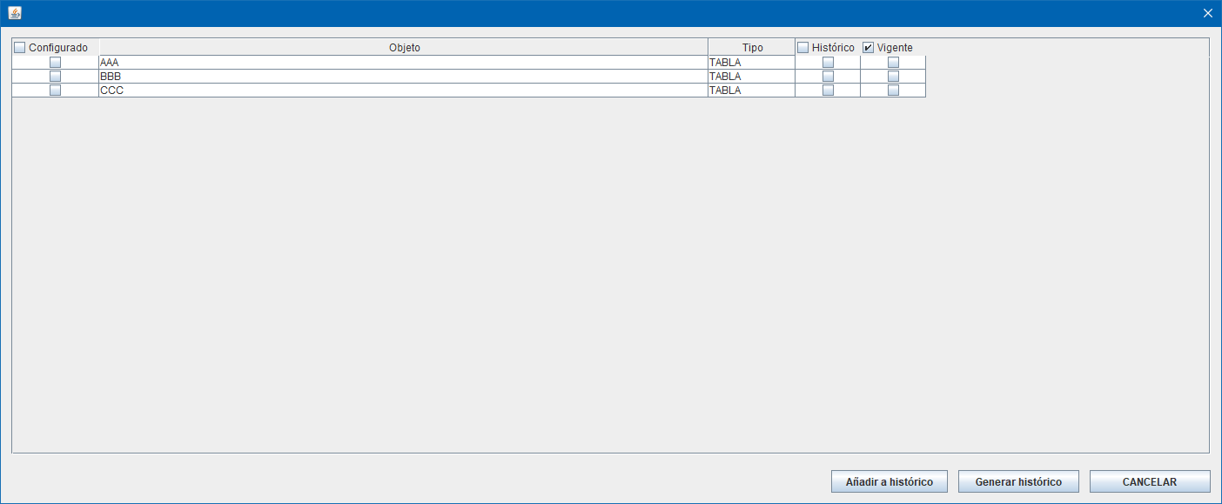

Si no se pueden ajustar, sacar los check del listado y ponerlos encima, pero manteniendo su comportamiento descripto en el documento. Por ejemplo:

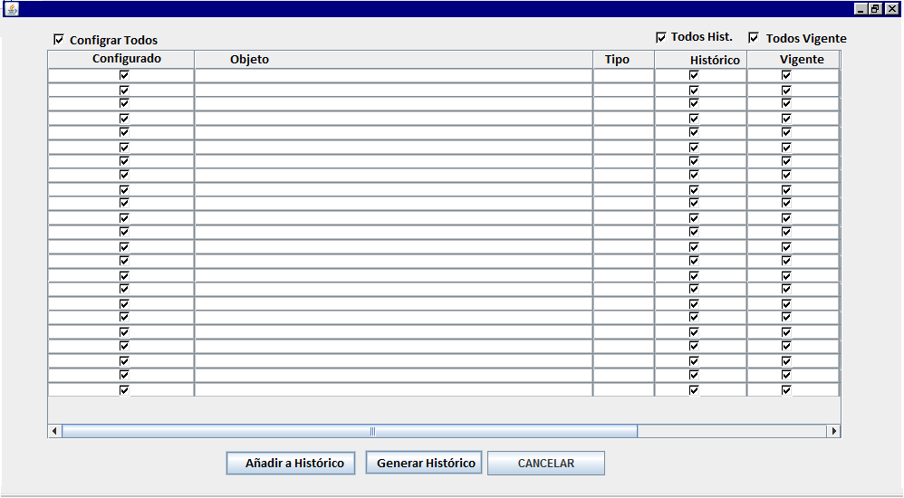

1. En el documento se indica: “Por defecto todos los objetos tienen seleccionado el check de Vigente.” Actualmente aparece seleccionado el check de seleccionar todo de Vigente únicamente. **Esta incidencia ya estaba reportada y no se ha solucionado.**

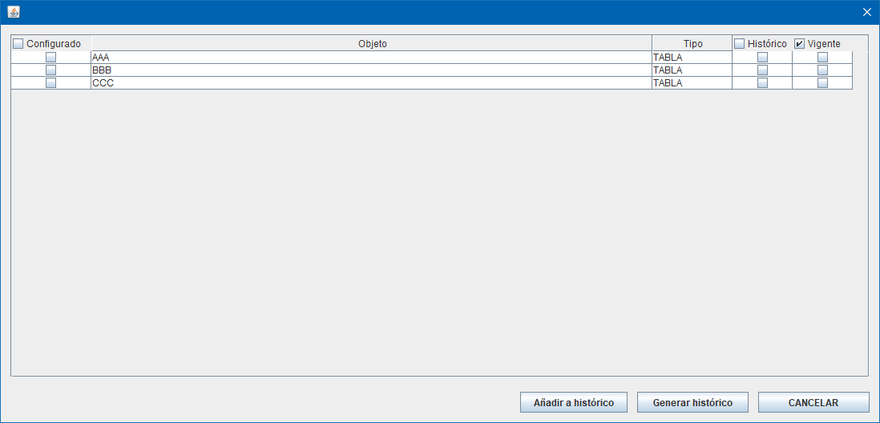

1. Si se selecciona en alguna tabla su check de histórico, se produce un error al invocar al procedimiento p_alta_historico. Se está informando a null el cod_peticion. Este dato se saca del procesado en curso, al igual que el proyecto. Esta es la traza:

16:31:15.844 [AWT-EventQueue-0] INFO c.m.b.service.impl.ServiceSupport - {call SM2_K_LD_MDSQL_MARIPAM.P_ALTA_HISTORICO(?,?,?,?,?,?)}

16:31:15.845 [AWT-EventQueue-0] INFO c.m.b.service.impl.ServiceSupport - Parßmetros de entrada:

[SeleccionHistorico(configurado=false, objeto=AAA, tipo=TABLA, historico=true, vigente=true, editable=true), SeleccionHistorico(configurado=false, objeto=BBB, tipo=TABLA, historico=true, vigente=true, editable=true), SeleccionHistorico(configurado=false, objeto=CCC, tipo=TABLA, historico=false, vigente=true, editable=true)]

MDSQL_TRON21

NULL

MARIPAM

1. Si no seleccionamos ningún fichero para añadir a histórico y marcamos todos para Vigente, si damos al botón Generar Histórico se produce el siguiente error tras confirmar la operación:

Exception in thread "AWT-EventQueue-0" java.lang.NullPointerException

at com.mdsql.ui.listener.PantallaProcesarScriptActionListener.procesarScript(PantallaProcesarScriptActionListener.java:387)

at com.mdsql.ui.listener.PantallaProcesarScriptActionListener.eventBtnProcesar(PantallaProcesarScriptActionListener.java:172)

at com.mdsql.ui.listener.PantallaProcesarScriptActionListener.actionPerformed(PantallaProcesarScriptActionListener.java:93)

at javax.swing.AbstractButton.fireActionPerformed(Unknown Source)

at javax.swing.AbstractButton$Handler.actionPerformed(Unknown Source)

at javax.swing.DefaultButtonModel.fireActionPerformed(Unknown Source)

at javax.swing.DefaultButtonModel.setPressed(Unknown Source)

at javax.swing.plaf.basic.BasicButtonListener.mouseReleased(Unknown Source)

at java.awt.Component.processMouseEvent(Unknown Source)

at javax.swing.JComponent.processMouseEvent(Unknown Source)

at java.awt.Component.processEvent(Unknown Source)

at java.awt.Container.processEvent(Unknown Source)

at java.awt.Component.dispatchEventImpl(Unknown Source)

at java.awt.Container.dispatchEventImpl(Unknown Source)

at java.awt.Component.dispatchEvent(Unknown Source)

at java.awt.LightweightDispatcher.retargetMouseEvent(Unknown Source)

at java.awt.LightweightDispatcher.processMouseEvent(Unknown Source)

at java.awt.LightweightDispatcher.dispatchEvent(Unknown Source)

at java.awt.Container.dispatchEventImpl(Unknown Source)

at java.awt.Window.dispatchEventImpl(Unknown Source)

at java.awt.Component.dispatchEvent(Unknown Source)

at java.awt.EventQueue.dispatchEventImpl(Unknown Source)

at java.awt.EventQueue.access$500(Unknown Source)

at java.awt.EventQueue$3.run(Unknown Source)

at java.awt.EventQueue$3.run(Unknown Source)

at java.security.AccessController.doPrivileged(Native Method)

at java.security.ProtectionDomain$JavaSecurityAccessImpl.doIntersectionPrivilege(Unknown Source)

at java.security.ProtectionDomain$JavaSecurityAccessImpl.doIntersectionPrivilege(Unknown Source)

at java.awt.EventQueue$4.run(Unknown Source)

at java.awt.EventQueue$4.run(Unknown Source)

at java.security.AccessController.doPrivileged(Native Method)

at java.security.ProtectionDomain$JavaSecurityAccessImpl.doIntersectionPrivilege(Unknown Source)

at java.awt.EventQueue.dispatchEvent(Unknown Source)

at java.awt.EventDispatchThread.pumpOneEventForFilters(Unknown Source)

at java.awt.EventDispatchThread.pumpEventsForFilter(Unknown Source)

at java.awt.EventDispatchThread.pumpEventsForFilter(Unknown Source)

at java.awt.WaitDispatchSupport$2.run(Unknown Source)

at java.awt.WaitDispatchSupport$4.run(Unknown Source)

at java.awt.WaitDispatchSupport$4.run(Unknown Source)

at java.security.AccessController.doPrivileged(Native Method)

at java.awt.WaitDispatchSupport.enter(Unknown Source)

at java.awt.Dialog.show(Unknown Source)

at java.awt.Component.show(Unknown Source)

at java.awt.Component.setVisible(Unknown Source)

at java.awt.Window.setVisible(Unknown Source)

at java.awt.Dialog.setVisible(Unknown Source)

at com.mdval.ui.utils.UIHelper.show(UIHelper.java:63)

at com.mdsql.ui.listener.FramePrincipalActionListener.evtProcesarScript(FramePrincipalActionListener.java:320)

at com.mdsql.ui.listener.FramePrincipalActionListener.actionPerformed(FramePrincipalActionListener.java:84)

at javax.swing.AbstractButton.fireActionPerformed(Unknown Source)

at javax.swing.AbstractButton$Handler.actionPerformed(Unknown Source)

at javax.swing.DefaultButtonModel.fireActionPerformed(Unknown Source)

at javax.swing.DefaultButtonModel.setPressed(Unknown Source)

at javax.swing.plaf.basic.BasicButtonListener.mouseReleased(Unknown Source)

at java.awt.AWTEventMulticaster.mouseReleased(Unknown Source)

at java.awt.Component.processMouseEvent(Unknown Source)

at javax.swing.JComponent.processMouseEvent(Unknown Source)

at java.awt.Component.processEvent(Unknown Source)

at java.awt.Container.processEvent(Unknown Source)

at java.awt.Component.dispatchEventImpl(Unknown Source)

at java.awt.Container.dispatchEventImpl(Unknown Source)

at java.awt.Component.dispatchEvent(Unknown Source)

at java.awt.LightweightDispatcher.retargetMouseEvent(Unknown Source)

at java.awt.LightweightDispatcher.processMouseEvent(Unknown Source)

at java.awt.LightweightDispatcher.dispatchEvent(Unknown Source)

at java.awt.Container.dispatchEventImpl(Unknown Source)

at java.awt.Window.dispatchEventImpl(Unknown Source)

at java.awt.Component.dispatchEvent(Unknown Source)

at java.awt.EventQueue.dispatchEventImpl(Unknown Source)

at java.awt.EventQueue.access$500(Unknown Source)

at java.awt.EventQueue$3.run(Unknown Source)

at java.awt.EventQueue$3.run(Unknown Source)

at java.security.AccessController.doPrivileged(Native Method)

at java.security.ProtectionDomain$JavaSecurityAccessImpl.doIntersectionPrivilege(Unknown Source)

at java.security.ProtectionDomain$JavaSecurityAccessImpl.doIntersectionPrivilege(Unknown Source)

at java.awt.EventQueue$4.run(Unknown Source)

at java.awt.EventQueue$4.run(Unknown Source)

at java.security.AccessController.doPrivileged(Native Method)

at java.security.ProtectionDomain$JavaSecurityAccessImpl.doIntersectionPrivilege(Unknown Source)

at java.awt.EventQueue.dispatchEvent(Unknown Source)

at java.awt.EventDispatchThread.pumpOneEventForFilters(Unknown Source)

at java.awt.EventDispatchThread.pumpEventsForFilter(Unknown Source)

at java.awt.EventDispatchThread.pumpEventsForHierarchy(Unknown Source)

at java.awt.EventDispatchThread.pumpEvents(Unknown Source)

at java.awt.EventDispatchThread.pumpEvents(Unknown Source)

at java.awt.EventDispatchThread.run(Unknown Source)

**Esta incidencia ya estaba reportada y no se ha solucionado.**

1. Se prepara una invocación al procedimiento P_SEL_HISTORICO para que devuelva un aviso para mostrar por pantalla, pero no se muestra al mensaje. Este funcionamiento de los avisos es común para todas las invocaciones a la lógica en toda la aplicación.